**Vibration and Acoustic data for defect cases of the cylindrical roller bearing**

**Anil Kumar and Rajesh Kumar**

**Precision Metrology Laboratory, Mechanical Engineering Department,**

**Sant Longowal Institute of Engineering and Technology, Longowal, India**

**Data can be downloaded from**

**Google drive:** [**https://drive.google.com/file/d/1IZ5Ox1k_ctfpXEcWwTesru_FEJ-88neL/view?usp=sharing**](https://drive.google.com/file/d/1IZ5Ox1k_ctfpXEcWwTesru_FEJ-88neL/view?usp=sharing)

**Microsoft One Drive:** [**https://1drv.ms/u/s!Aqapr1km1L_91CMsLPx9BR9dNL16?e=1NhxB1**](https://1drv.ms/u/s!Aqapr1km1L_91CMsLPx9BR9dNL16?e=1NhxB1)

**Baidu Network Disk Drive**:[**https://pan.baidu.com/s/1bj1WxZgasdd6J56o0f8mMw**](https://pan.baidu.com/s/1bj1WxZgasdd6J56o0f8mMw)

**Password Code for Baidu**: 1234

**Introduction**: This document has description of cylindrical roller bearing (NBC: NU205E) defect data, the Test rig facility, sensor, and data acquisition device located at Precision Metrology Laboratory, Mechanical Engineering Department of Sant Longowal Institute of Engineering and Technology Longowal, India. This data can have the following applications:

* Test the performance of various signal processing techniques.
* Defect width measurement using vibration data
* Development of Artificial intelligence models for defect identification
* Performance of AI model can be tested on unseen data.   
  For example, an AI model which is developed from conditions mentioned in **Table 2** can be used to check the accuracy of the model using unseen data for condition mentioned in **Table 3.**

1. **Test Rig**

Fig. 1 is the typical photograph of the rolling element bearing test rig. Its schematic diagram is shown in Fig. 2. The shaft is supported by two bearings at its end (bearing 1 and bearing 2). A 346-Watt AC motor provides power to the shaft. The power from the motor is transferred to the shaft via a step pulley arrangement. In the middle of the shaft (between bearings 1 and 2), a 2 kg disc is attached to the shaft and rotates with it. A lever arrangement is used to load the bearing in the vertical direction. A load cell is located beneath the bearing housing on the test rig to measure the applied load. The test rig has a proximity sensor for the measurement of shaft speed. The vibration signals from the test rig were measured by mounting an accelerometer on the top of the bearing housing. All the signals acquired in this work were recorded at a sampling rate of 70000 samples/sec.

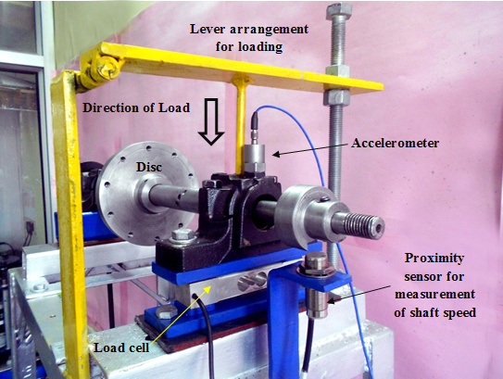

**Fig. 1**. A typical photograph of the test rig

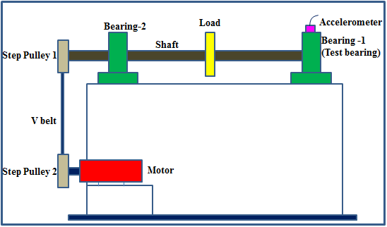

**Fig. 2**. A typical photograph of the test rig

1. **Test Bearing**

The test bearing is a cylindrical roller bearing (NBC: NU205E). The specifications of the bearing under study are given in **Table 1**. A total of twelve defect cases were studied, the detail of which is given in **Table 2.** All the defects are in the form of rectangular grooves which are produced by the Electric discharge machining (EDM) process. The defective components of bearing under study are shown in **Fig. 3-5.** The experiment was conducted at a shaft speed of 2050 rpm and at a vertical load of 200 N. -

The conditions listed in **Table 2** can be used to construct (train and test) an AI model. Testing of the same model can be done to assess how well it performs with unknown data. **Table 3** has details of data that can be used as unseen data. The concept of transfer learning can also be used here.

**Table 1**: Specifications of the cylindrical rolling bearing under study (NBC: NU205E)

|  |  |
| --- | --- |
| Diameter (Inner race) | 25 mm |
| Diameter (Outer race) | 52 mm |
| Pitch Diameter (D) | 38.9 mm |
| Ball Diameter (d) | 7.5 mm |
| Number of rolling elements (N) | 13 |
| Contact angle () | 0 |

**Table 2**: Defect cases of the cylindrical roller bearing understudy obtained at a shaft speed of 2050 rpm and load of 200 N

|  |  |  |
| --- | --- | --- |
| Bearing component | Label | Defect width  (in mm) |
| Inner race | IR-I | 0.43 |
| IR-II | 1.01 |
| IR-III | 1.56 |
| IR-IV | 2.03 |
| Outer race | OR-I | 0.42 |
| OR-II | 0.86 |
| OR-III | 1.55 |
| OR-IV | 1.97 |
| Roller | RO-I | 0.49 |
| RO-II | 1.16 |
| RO-III | 1.73 |
| RO-IV | 2.12 |

**Table 3**. Defect sizes of the cylindrical roller bearing different from the cases mentioned in the **Table 2**.

|  |  |  |
| --- | --- | --- |
| Defective component | Label | Defect size  (in mm) |
| Inner race | IR-V | 1.85 mm |
| Outer race | OR-V | 1.34 mm |
| Roller | RO-V | 0.75 mm |

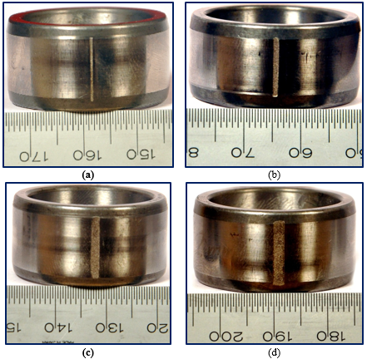

**Fig. 3**. Typical photographs of inner races having defect (a) IR-I defect (b) IR-II defect (c) IR-III defect and (d) IR-IV defect

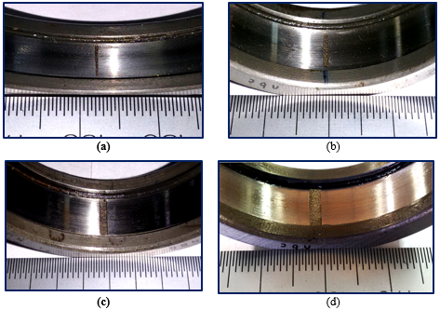

Fig. 4. Typical photographs of outer races having defect (a) OR-I defect (b) OR-II defect (c) OR-III defect and (d) OR-IV defect

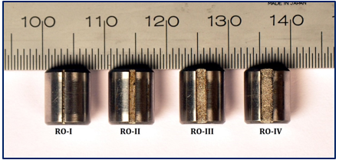

**Fig. 5.** A typical photograph of defective rollers

1. **Data Acquisition device:** The data acquisition device used to acquire vibration and acoustic data is NI-USB-4431, which is a portable data acquisition device and is shown in Fig. 6. The NI-USB-4431 has signal conditioning modules with a low-pass Bessel filter for aliasing reduction.

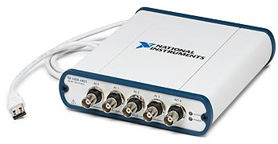

**Fig. 6**. A typical photograph of DAQ (NI-USB-4431)

The device has 4 input channels (ai0, ai1, ai2, and ai3) that can acquire voltage in the range of ±10 V. It has 1 analog output channel (±3.5 V) and has a sample update rate of 96 kS/s. The device has 24-bit resolution and has software-selectable IEPE signal conditioning (0 or 2.1 mA).

1. **Acoustic and Vibration Sensor**

Acoustic and vibration data were recorded using a microphone and tri-accelerometer which can record the data in three axes.

The Acoustic emission sensor used for acquiring the data is shown in Figure 7 and is connected to ai3 channel of accelerometer. The specification of the microphone is shown in Table 4.

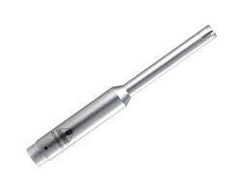

**Fig. 7.** Microphone used for data acquisition

**Table 4.** Specifications of microphone

|  |  |
| --- | --- |
| Manufacturer | BEHRINGER |
| Model No. | ECM8000 |
| Type | Electret Condenser |
| Polar pattern | Omni-directional |
| Impedance | 600 Ohms |
| Sensitivity | -60 db |
| Frequency response | 15 Hz - 20 kHz |
| Phantom Power | +15 V to +48 V |
| Weight | 0.120 kg |

The accelerometer is a lightweight (1.0 gm) miniature, ceramic shear ICP® Triaxial accelerometer (model no PCB3456A01) having a sensitivity of 5 mV/g, Sensitivity: (±20%) 5 mV/g (0.51 mV/(m/s²)) and Measurement Range: ±1000 g pk ( ±9810 m/s² pk). Fig. 8 shows a typical photograph of the accelerometer.

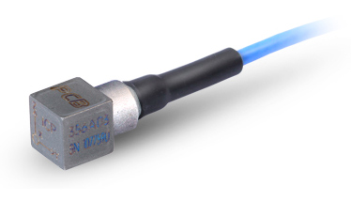

Vertical direction connected to ai0 channel

Horizontal direction connected to ai1 channel

Axial direction (Shaft axis direction) connected to ai2 channel

**Fig. 8.** Accelerometer used for data acquisition

**Interested researchers who intend to use this data should cite following relevant publications**

1. **Anil Kumar,** Yuqing Zhou, C.P. Gandhi, Rajesh Kumar, Jiawei Xiang. (2020) Bearing defect assessment using wavelet transform based deep convolutional neural network (DCNN). Alexandria Engineering Journal 59, 999–1012 (Elsevier). **I.F.: 3.73** ISBN: 1110-0168. Available online at: <https://doi.org/10.1016/j.aej.2020.03.034>
2. **Anil Kumar** and Rajesh Kumar (2017) Enhancing weak defect features using undecimated and adaptive wavelet transform for estimation of roller defect size in a bearing. Tribology Transactions. 60(5): 794-806 (**Taylor and Francis publication, Impact Factor: 1.96**). Available online at: <http://doi.org/10.1080/10402004.2016.1213343>. ISBN: 1547-397X
3. **Anil Kumar** and Rajesh Kumar (2017) Least Square Fitting for Adaptive Wavelet Generation and Automatic Prediction of Defect Size in the Bearing Using Levenberg–Marquardt Backpropagation. Journal of Nondestructive Evaluation. *36* 7: 1-16 (**Springer publication, Impact Factor:** 1.99). Available online at: <http://doi.org/10.1007/s10921-016-0385-1>. ISBN: 1573-4862

**Contributors**

**Associate Professor (Dr.) ANIL KUMAR**

**SCOPUS ID:** [**https://www.scopus.com/authid/detail.uri?authorId=57202522777**](https://www.scopus.com/authid/detail.uri?authorId=57202522777)

**Email: anil_taneja86@yahoo.com**



**Professor (Dr.) Rajesh Kumar**

**SCOPUS ID:** [**https://www.scopus.com/authid/detail.uri?authorId=7406019891**](https://www.scopus.com/authid/detail.uri?authorId=7406019891)